Nicholas Skinner

CS453

Spring 2019

**Project #4 - Hyperbolic Geometry**

**Final Assignment Images:**

Below are a series of images to display my assignment submission. A map of the united states in both polar and cartesian space. I tried to display all the features needed for the assignment including: drawing a map, Polar space, Cartesian space, Translation, spinner ‘zoom’ and the extra credit.

**US Map:**

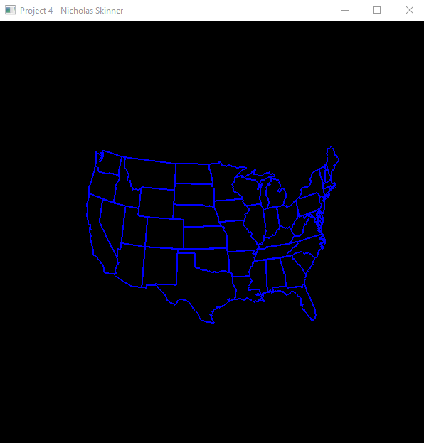

**Polar Space:**

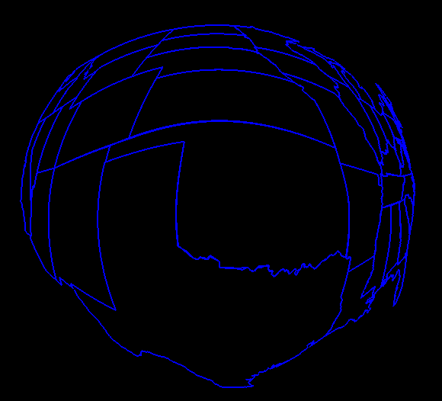

**Cartesian Space:**

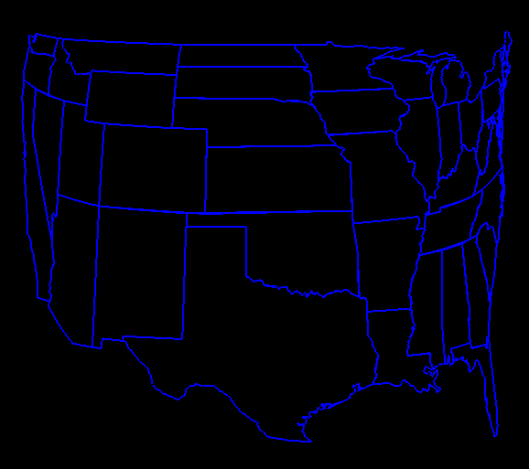

**Translation:**

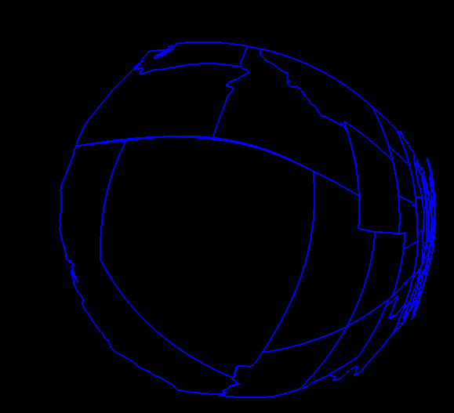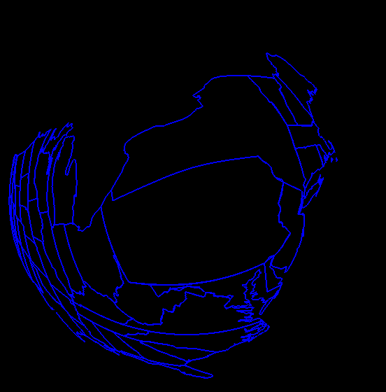

**Spinner:**



**Extra Credit:**

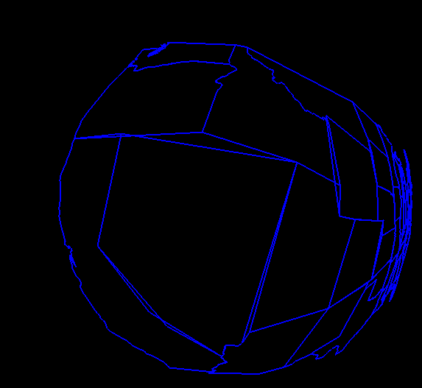

**Reflection:**

This assignment had a few moments of confusion fo me, but those were just due to needing to change the display locations and other components of the display() method. Overall, with the instructors slides on how to implement each system, visualization went fairly well. For controls, I placed a kvalue spinner at the top, and used the Trans XY slider on the bottom for my movement across the object. The High definition button implements the extra credit option of making the lines between the states more seamless.

Video link: <https://media.oregonstate.edu/media/t/0_48qew69u>